Project Development Phase
Model Performance Test
Date | 3 October 2026
Team ID | SWTID-2026-5226
Project Name | Import Data using Transform Maps (Spreadsheet)
Maximum Marks
Model Performance Testing:
Project team shall fill the following information in model performance testing template.
S.No. | Parameter | Values | Screenshot
1. | Transform Map Summary | Transform Map: Sample Spreadsheet Import  Source table: Employee Import (u_employee_import)  Target table: Employee Test (u_employee_test)  Fields mapped (5): Employee ID, Employee Name, Email, Department, Location (Auto Map Matching Fields) | 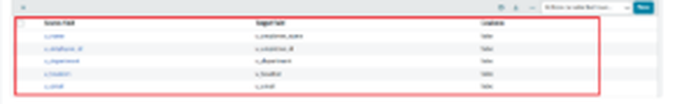
2. | Import Accuracy | First import (new and changed data):  Total rows - 4  Inserted - 2 (two new Employee IDs)  Updated - 2 (same IDs, changed Name and Email)  Skipped - 0  Re-import of the same sheet:  Total rows - 4  Inserted - 0, Updated - 0  Ignored - 4 | 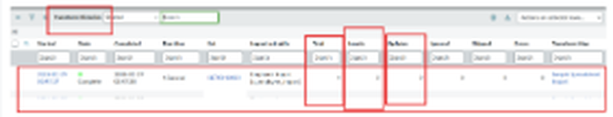  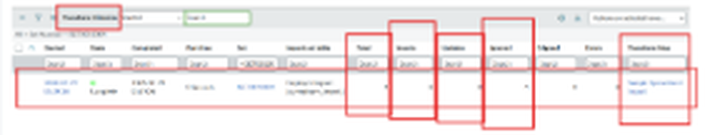
3. | Fine Tuning Result (if Done) | Coalesce enabled on the Employee ID field map  Result - existing records are updated and no duplicate records are created when the same data is imported again | 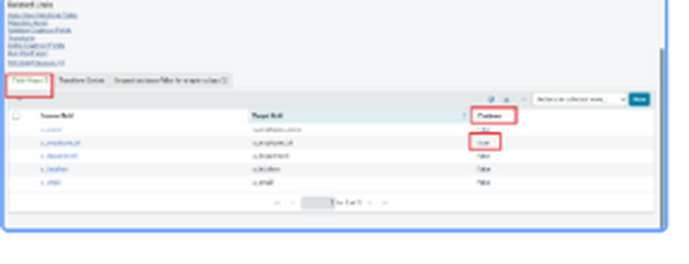
4. | Report Output | Report: Employees by Department  Type: Pie chart, Group by Department, Aggregation: Count  Result - report runs and is saved; shown on a dashboard | 